**Test assignment:**

Main objective for this test assignment is to demonstrate your ability to develop and work with WebGL technology. Sample scene is attached with all additional files. I will be available for any additional questions you may have. The purpose of this test is to discover your potential and abilities since real projects will be more demanding and/or bigger to resolve therefore I hope you will take this small project seriously and if you have any suggestions on how to improve attached scene, feel free to demonstrate all your abilities.

Within attached model there is several important point to consider. If you cannot resolve any of the points, please let me know the details.

**General result:**

Camera needs to freely orbit around the house but consider movement restraint on vertical angle of camera rotation since users shouldn’t fall under walking plane. Zoom wheel should be able to slightly zoom in and out with option to click on interactive elements. Also in general view there should be BACK button, along with DOWNLOAD button to allow users to download PDF file attached.

When user clicks at the roof, roof will be lifted and reveal floorplan with three purple markers. If mouse pointer is placed over the marker, the marker itself should be changed in colour/shader or some other way indicating it is ‘clickable’. This means also that you may have to consider collisions in the scene since there are purple markers hidden under the roof and are not available until the roof is lifted. Clicking on the marker will trigger 360 panorama provided within .max file. If you can resolve this problem in other way, please demonstrate how to be more efficient or better/easier.

User must be always able to use back button in order to return one step backwards and if you think that it would be useful to have home button which will get user back to starting position, make it so.

**Interactive elements are:**

* Roof (when clicked animated move upwards is required, if clicked upon elevated roof element, animation will bring back the model to starting position) 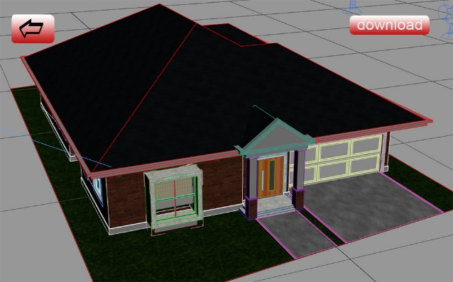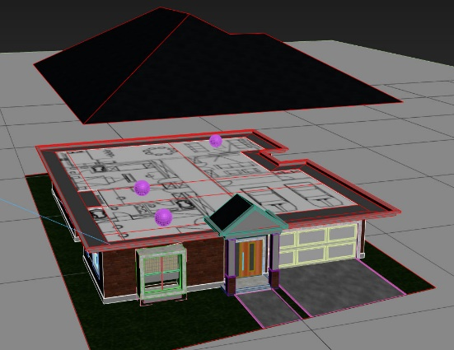
* 360 panorama markers (marked with purple spheres which loads 360 panorama already assigned to cube 3d models already within the scene. When inside panorama view there should be back button somewhere in the viewport in order to get the user back to overall model view) 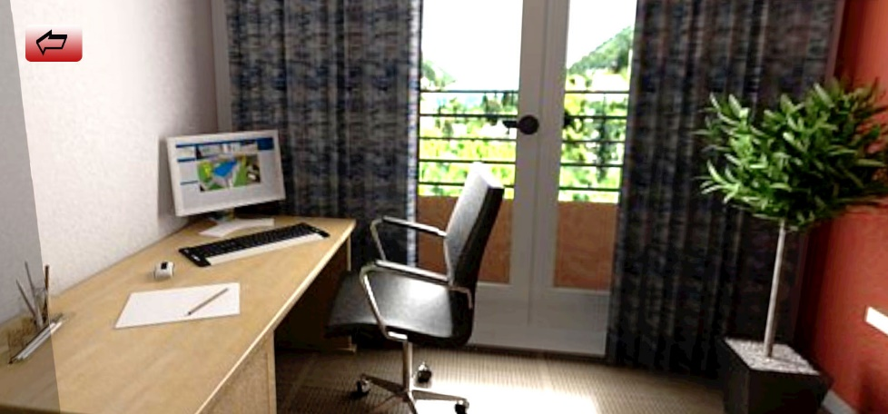
* Floorplan plane (when clicked upon it should load floorplan image in front of the main view the user is currently in showing full resolution floorplan image. Also above the floorplan image there should be small text box (not an image of text) with brief description. /Text is as follows: NOTES ON THE PLAN Reposition the trees to lot border instead proposed central position which makes difficult to design any kind of driveway to the lot./